**Non Motor Dynamic Screen Configuration**

Screen Link - <http://192.168.1.99:4020/>

Admin Login – admin02 / Admin@01

For Configuring a Project – need to create Project Details under Modules Menu Section

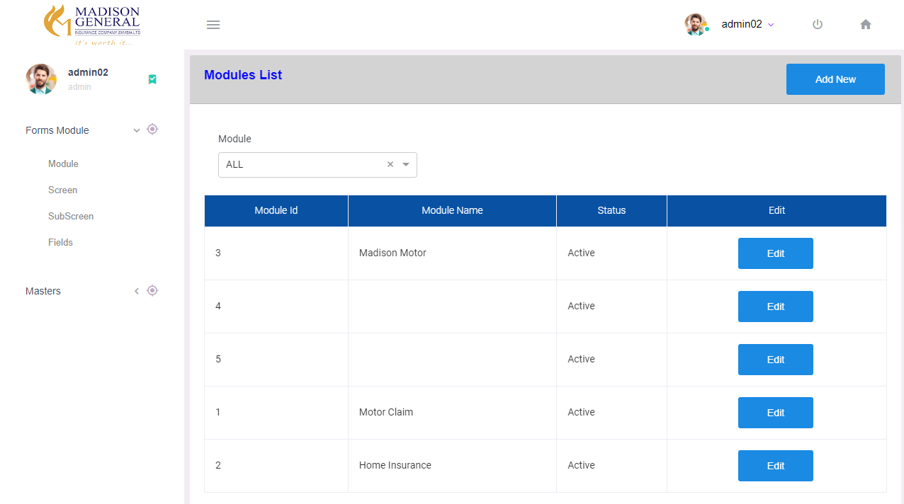

Click Add New button For Add New Project Details

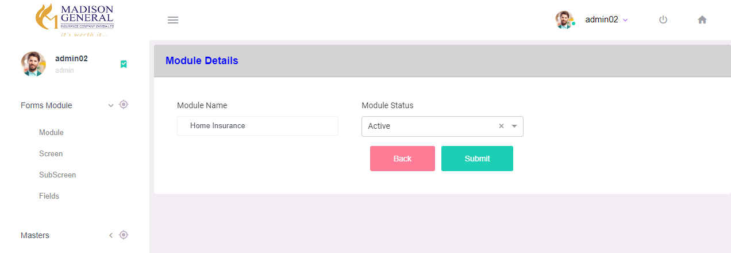

Each Project Will Contains Multiple Screen Section – Existing Screen List can Be Found under Screen menu Based on Project Selection

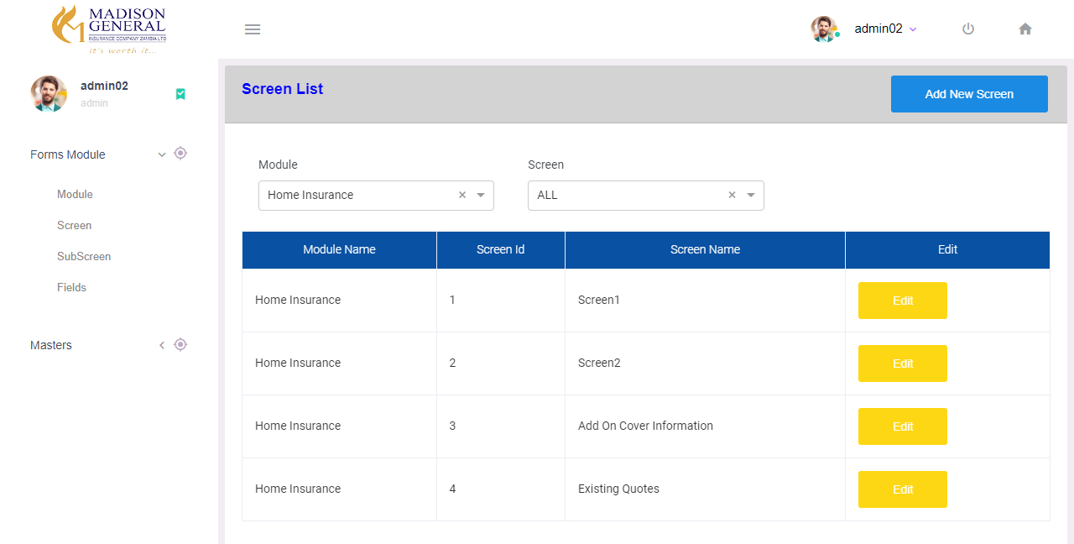

Click Add New Screen for Adding New Screen on the Selected Project

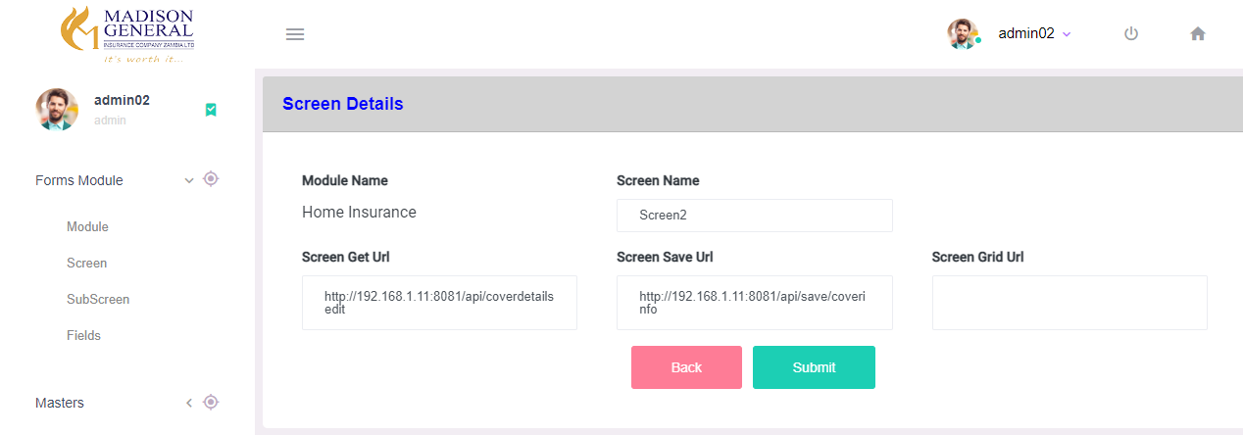

Screen Name – Screen Name is Stored to Display as Main Title on Rendering Page

Screen Save Url – If Screen Contains Any Form the save api url is stored in this field

Screen Get Url – If Screen contains Any FormSection – to get the saved details the api urll stored in this field

Screen Grid Url – If Screen Contains any Table – Get table Details Api Url stored in this field

Each Screen will contains Single or Multiple SubScreen Section – View Subscreen Details Based on Project & Screen Name in SubScreen Menu

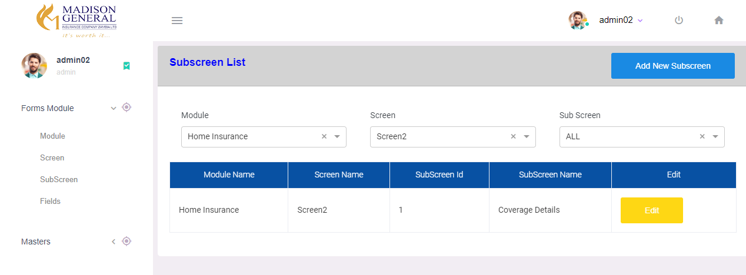

For Add new SubScreen – Click Add New SubScreen

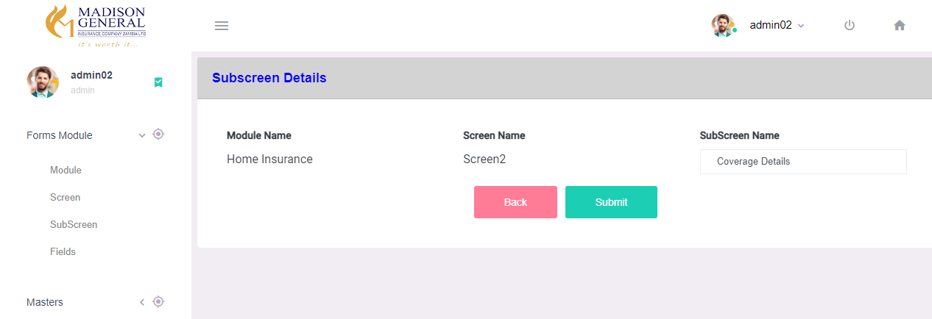

SubScreen Name – Name Stored to Display as Sub-Screen Title on Rendering Page

If Sub-Screen Contains Any Form Section – Single or Multiple Fields Can be Configured to the Respective Sub-Screen

Existing Fields List can be Found on Fields Menu – Based on Project, Screen, SubScreen Selection

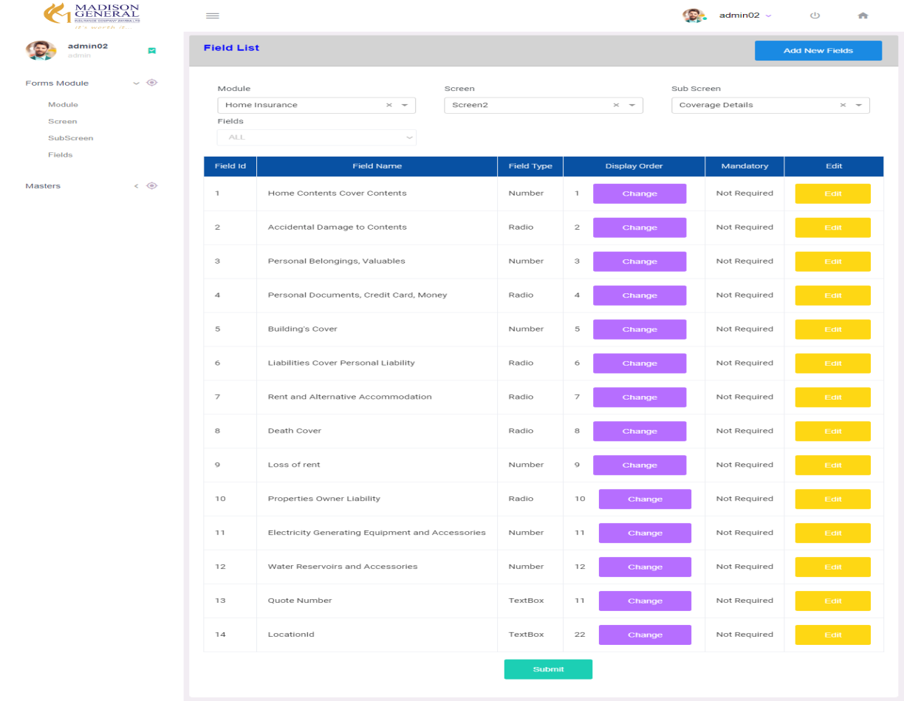

Click on Add New Fields – For New Field Insert

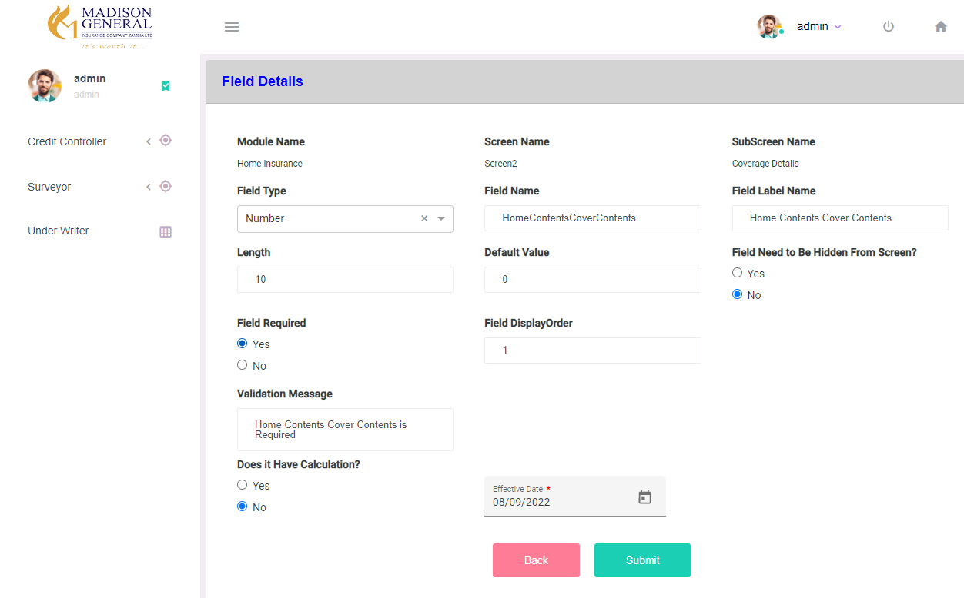

Field Type - Field Type can Be TextBox, TextArea, Radio, Dropdown, DatePicker,Checkbox

* Based On Field Type Selection Field Details will be Shown

Field Name – Value Stored to pass as Key in Submit Api

Field Label Name – Value Stored to Display Label Name for field on Rendering Page

Length – Maximum Length of Field

Default Value – If Field contains Any Static Value, it can be Stored

FieldneedtoBeHidden? – Based on Selection Fields Can be Shown/Hidden on Screen

FieldRequired? – Field Mandatory or not

Validation Message – Based on Field Required Selection Validation Message Field Shown – Mandatory Message are Stored to display for empty Validations

Display Order – Field can be Displayed in Screen Based on the DisplayOrder value

If Field Type – Dropdown/Radio -

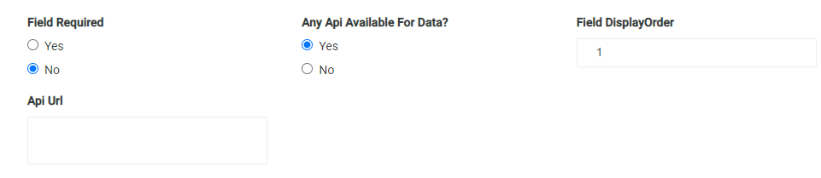

Any Api Available? – If Dropdown/Radio Field Option is load by any Api

Api Url – Url for Dropdown Api Call

If there is no Api Available – Static Options Can be Stored as Shown Below

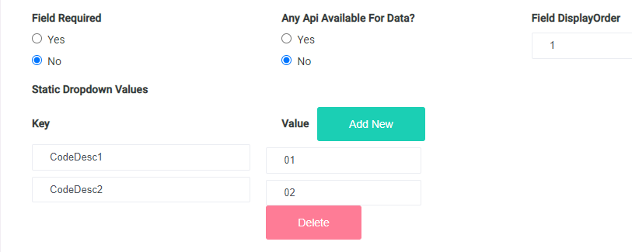

Does it Have Calculation? – If Field Contains any Inbuilt Api Calculation – this can be Selected

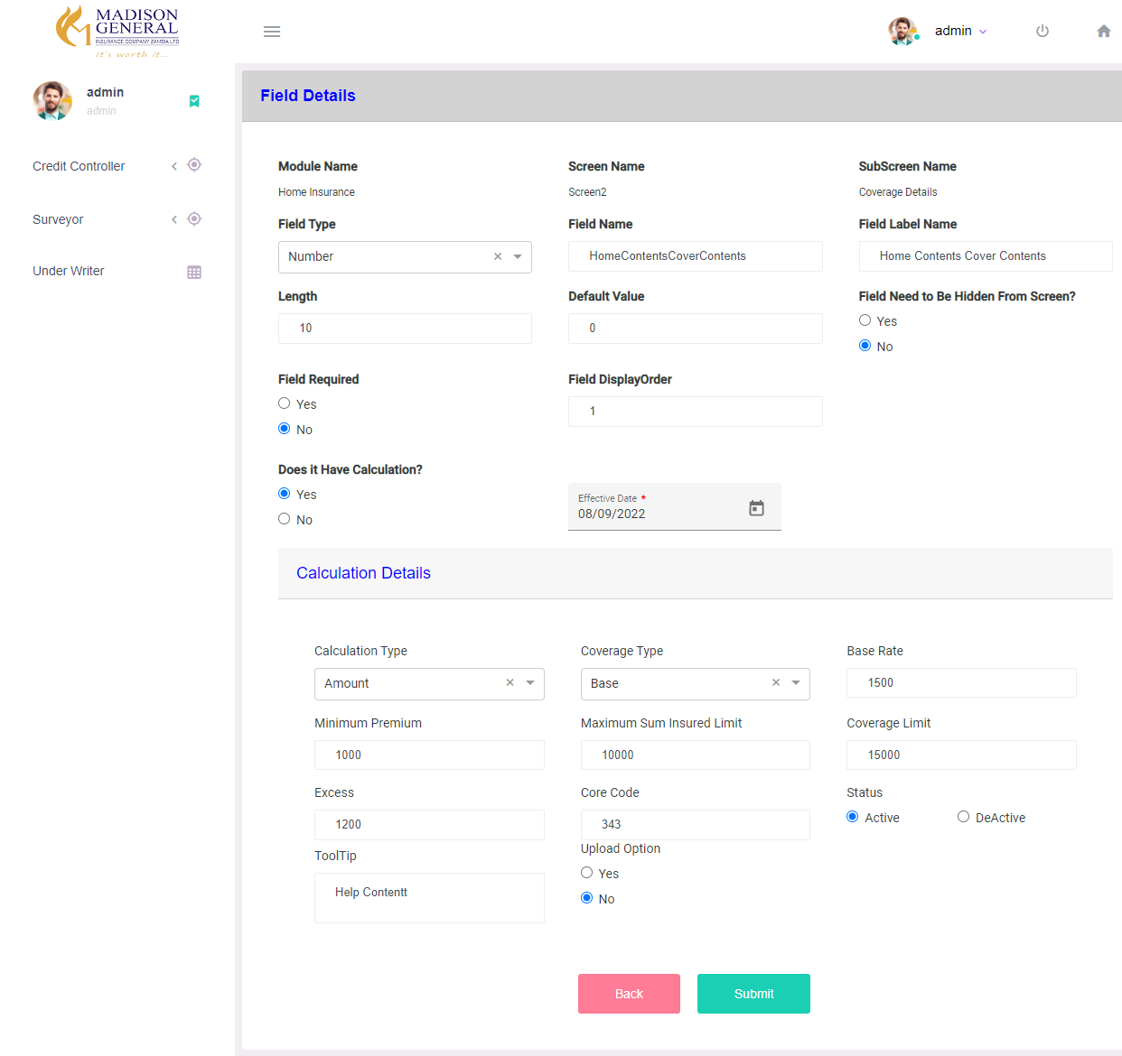

Calculation Details –

CalculationType – If typeOf calculation is Amount / Mile / Percentage

BaseRate, Minimum Premium, Maximum SumInsuredLimit can be stored for Calculation

If Calculation Type is Grid – Minimum SI Limit, Max SI Limit, Min Premium, Base Rate Details can be stored as Multiple Rows as Shown Below